Microprocessor Tutorial

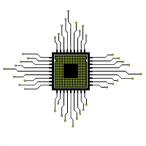

Our Microprocessor Tutorial is designed for beginners and professionals.

A microprocessor is a processor which incorporates the functions of a CPU on a single integrated circuit (IC).

Our Microprocessor tutorial includes all topics of Microprocessor such as introduction, features, types of microprocessor, architecture, applications, instruction set of 8085, instruction set of 8086, programming etc.